Introduction to Cyber Security

Introduction to Offensive Security
Perform directory brute-forcing on web applications

- Key Concepts
- Offensive Security = identifying vulnerabilities by simulating attacks
- Brute-force = systematically trying inputs to discover hidden resources
- Directory enumeration = finding hidden web pages

- Tools/Commands
Gobuster
- Command:
Gobuster command used to enumerate directories.
- Results from Gobuster scan
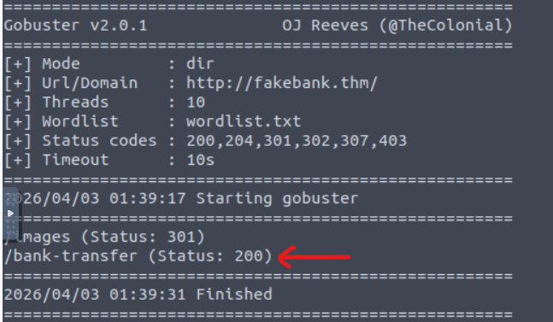
Scan results showing discovered endpoint /bank-transfer (Status 200).

- What I did:
- Performed directory brute-force attack against a web application
- Use a wordlist to enumerate hidden directories
- Identified /bank-transfer endpoint with HTTP 200 status

- What I learned:
- Directory enumeration can expose hidden and sensitive endpoints
- HTTP status codes (like 200) indicate valid pages
- Reconnaissance is a critical first step in web exploitation

- Job Relevance:
- Used in penetration testing to discover hidden attack surfaces
- Helps security analysts identify exposed endpoints and vulnerabilities
- Common technique in web application security assessments

